Instructions for Running the Dicom Reader Application:

Install PyCharm (Community Edition)

Link to download: <https://www.jetbrains.com/pycharm/download/#section=windows>

Once PyCharm is downloaded, do the following:

1. Select File (upper left corner)
2. Select New Project and configure setting as shown below. Then Select create:  
   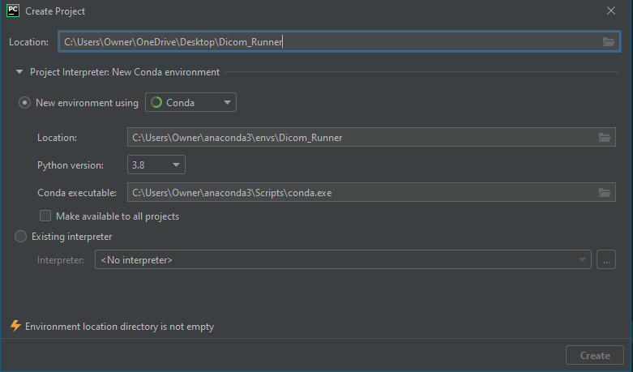  
   Note: you should be able to create a folder anywhere
3. Right Click on the Folder (in this example the folder is named Dicom_Runner) and select New->Directory. In this example I will be creating a Directory named files. The Project should then look like the picture shown below:  
   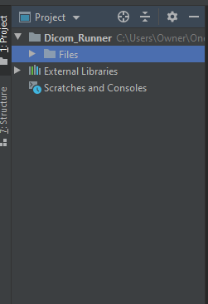
4. Add the following files to the directory from Github through File explorer (to find the File path to the project right click on the Directory Files and click “Show in explorer”):
   1. arial.ttf
   2. Button.py
   3. Dicom_Program.py (this is the driver file)
   4. normalize.py
   5. Read_Dicom.py
   6. windowsWorkArea.py

The directory should now look something like this:

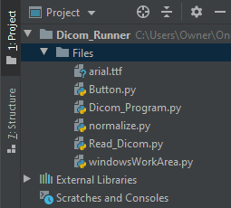

1. Install the Dependencies Using Pip.
   1. Right click the terminal button at the bottom. The location is shown below:  
      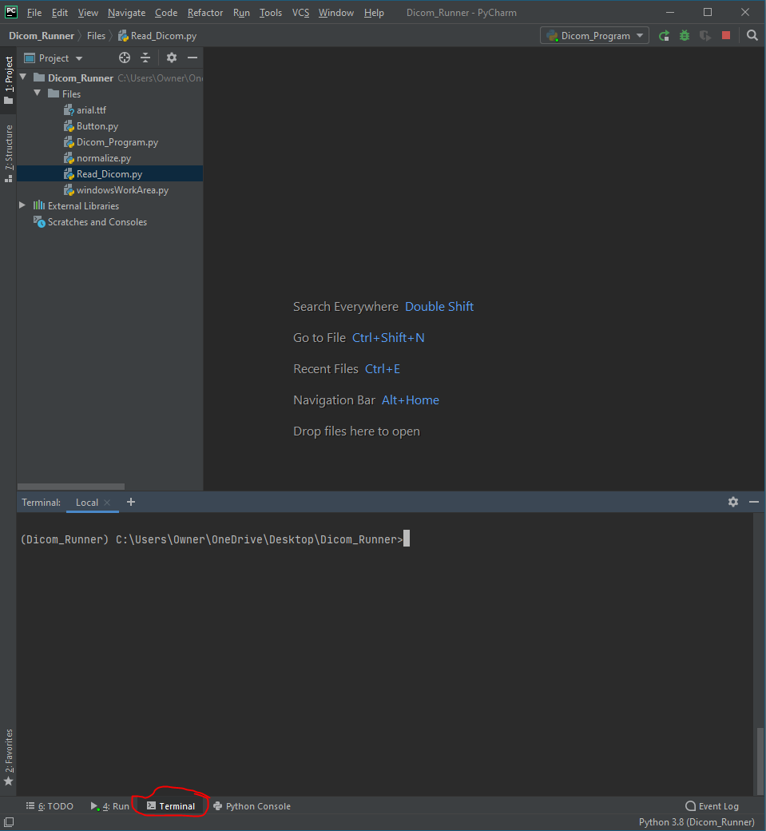
   2. Use the Command “pip install (module)” to install the following modules. Usage of pip install is shown below as well:  
      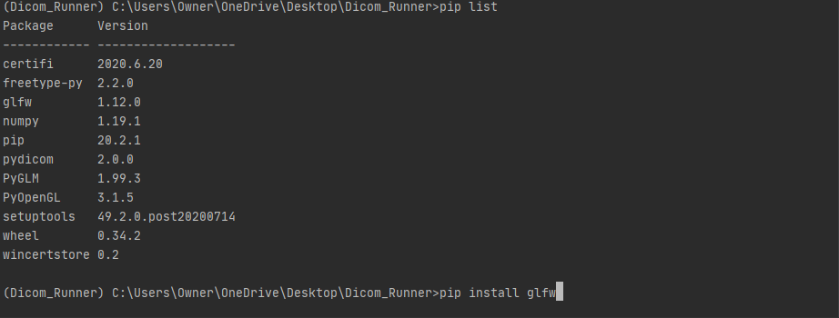
   3. Check whether you have all the modules by using pip list. Usage of this command is used in step 5b.
2. Right Click on Dicom_Program.py and click Run  
   Note: if it does not allow you to immediately run the program, you will need to set up a configuration for running.   
   To create a configuration, follow these steps.
   1. There should be a configuration button right around the area circled in red as shown below. You can also click run (on the banner at the top of the screen) and it should bring up the option to set the configuration.   
      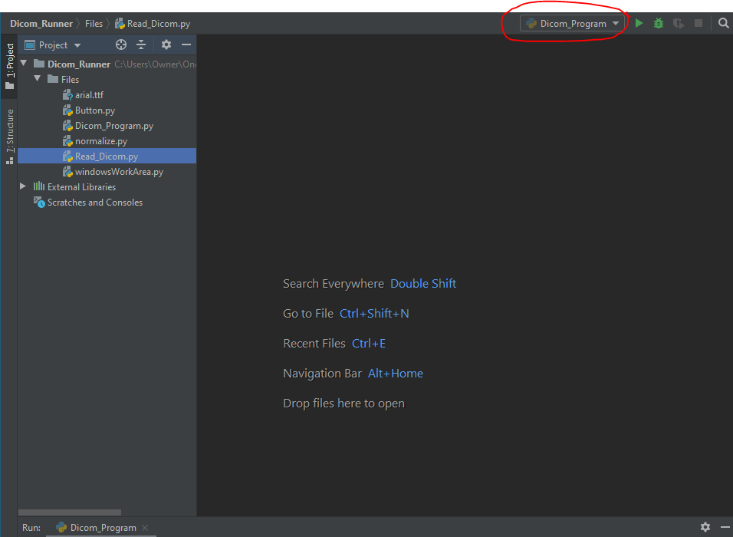
   2. Click the plus (+) to add a new configuration. Fill it out shown below  
      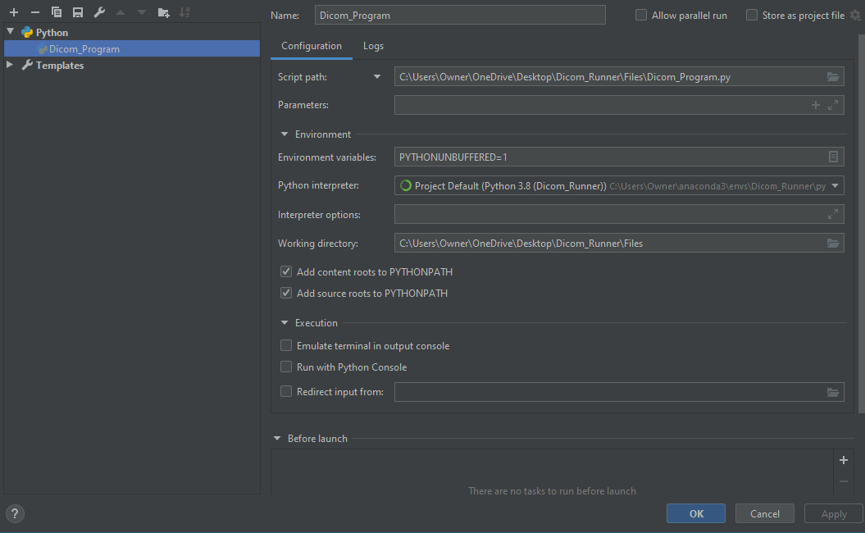
   3. You should now be able to run the program
3. If no errors occurred the program should look like this:

